Day 1

|  |
| --- |
| **Day 1** |

1. Who are 25th, 50th and 100th customers from top with respect to sum of sales in 2021?
2. Show the Top 3 products with respect to sum of quantity under each segment (Total 9 products) in West region.
3. Create new order date (e.g. if current year is 2023 then make sure new order date should have 2023) and show below columns in the text table.
   * Year
   * Quarter
   * Month
   * SUM(Sales)
   * YTD Sales
   * QTD Sales
   * MTD Sales
4. Show sub-category and region wise sum of profit in KPI indicator table as shown in below image. Use green circle for positive profit value and red circle for negative profit value.

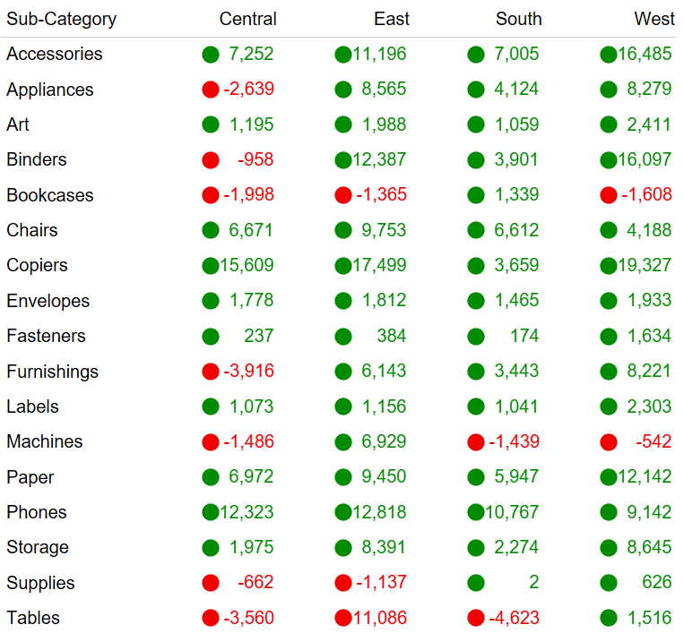

1. Show the Top N customers with respect to sum of quantity. The value N should be user-entered. Edit the title accordingly.
2. Answer in brief.
   * What is Replace References in tableau?
   * How to handle the NULL values for measures?
3. Analyse the purchasing capacity of customers by creating the bins of sales with bins size as 10. Show the bar chart of count of sales vs bins. The labels outside the bar chart should be shown in this format: 1,398 *(13.7%)*. Note that if any count of sales value is blank/null value then the bar chart should show 0.